MZ Blue Sterling  Sire: Urricelquis Mitchell, Reg.#K 04317  Dam: MZ Blue Winter, Reg.#K 03534  DOB: 02/29/12  Sex: Male  Color: Blue  Breed: Kelpie  Reg.#K 04699  Stud Fee $500.00 | 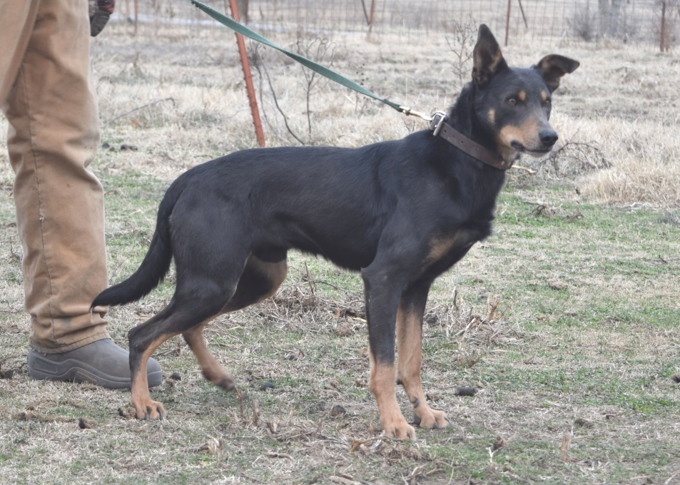

Urricelqui's Bullett,
B-9/1991
Hashknife Smoke,
A 00991
Hashknife Bonnie,
Jumakola Lucky Strike
A 03561
Triple S Jake,
K 01277 B-9/1998
Jumakola Tweed,
K 02426
Buchanan(US) Jenny,
Urricelquis Mitchell, K 04317 Blue '
LaPrele R Mike ,
A 00991
KT Smoke,
K 02359
Urricelqui's Jazz ,
Hall JC,
K 02826
Triple S Jake,
K 01277 B-9/1998
Jumakola Tweed,
K 02426
Buchanan(US) Jenny,
MZ Blue Sterling,
K 04699 Blue '12
Ref/ Wildwood Nick
Triple S Jake,
K 01277
Ref/ Winona US Jackie,
MZ Blue Winter,
K 03534
Urricelqui's Bullett,
B-9/1991
Hashknife Smoke,
A 00991
Hashknife Bonnie,
Jumakola Lucy,
K 03016
Jumakola Bud,
K 02526

Home | Stallions | Mares | Geldings | For Sale | Contact Us
© 2004 Gaylord Foundation Quarter Horses
Web Design by Kindred Spirits a Division of Hopkins Music
Last Updated: January 17, 2015

